**S4HANA Navigation:**

**By: Pankaj Kumar**

**Exercise 1**

What is the difference between the transactions *Display Current* and *Display at Key Date*? (2.5 points)

**Ans:-** SAP has the functionality to maintain the historical data i.e. time specific transactions so that the transaction changes can be tracked over time. Display Current shows the current state of the transaction or material chosen while Display at Key date helps you view the transaction for a given date in addition to material chosen which is specified by the user.

Display Current transaction can display all the data of the material master record but Display at Key Date cannot display document data, average plant stock etc.

**Exercise 2**

Create/Expand your own favorites menu.

* 1. Add the SAP Help Portal using the URL *help.sap.com*.
  2. Add the following transaction as a favorite:

Logistics ► Sales and Distribution ► Sales ► Order ► Display

Submit the screen shot to show the two additions (5 points)

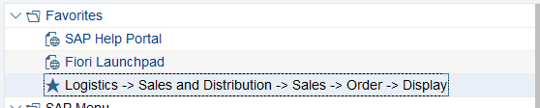

**Exercise 3**

* 1. What is the economic function behind transaction code VA03 (2.5 points)?  
     Display Sales Document
  2. What is the economic function behind the menu path: Logistics ► Sales and Distribution ► Master Data ► Business Partner ► Customer ► Display ► Complete? (2.5 points)  
     Customer Display: Initial Screen

**3.3.** Which operational processes are hidden behind the following transaction codes? (7.5 points)  
XK03: Display Supplier: Initial Screen  
MM02: Change Material (Initial Screen)  
ME23N: Display Purchase Order

**Exercise 4** For the following exercise switch to transaction VA03, to do so leave the current transaction by using .

How many sessions can be open in the system in parallel? (**Tipp** Click on the corresponding icon until the system does not create another session.) (2.5 points)  
**Ans:-** I am currently able to open 6 GUI windows as by default, maximum of 6 GUI windows/session can be launched to run in parallel. However, depending on the SAP system, settings can allow to open 2-30 windows to execute sessions in parallel.

**Exercise 5**

* 1. Call up transaction **VA01** and select the field *Distribution Channel*. Press the F1-button.   
     What is a distribution channel (in a few keywords)? (2.5 points)  
     A distribution channel is a way in which products or services reach the customer.

Example: Wholesale, Retail, or direct sales.

* 1. Close the window with definition of the Distribution Channel. Stay in transaction **VA01**. Click the field *Order Type* and press F4. What do the order types *SO* and *OR* stand for? (5 points)  
      SO Rush Order  
      OR Standard Order

5.3. What is the difference between these two types of orders? (2.5 points)  
In Rush Order, the goods delivery is expediated after the sales order is created but in Standard Order the customer can choose the delivery date while creating Sales Order and accordingly the delivery is done.

**Exercise 6**

* 1. How many black Deluxe Touring Bikes do you have in stock across Dallas and Miami plants? (2.5 points)  
     (**Tip** Therefore use transaction **MMBE**.)   
     **350**

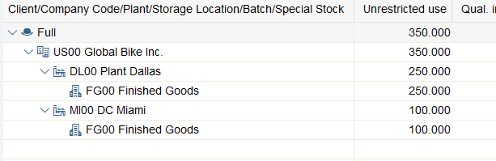

* 1. Which customers can be identified in GBI?  
     Follow the menu path: **Logistics** ► **Sales and Distribution** ► **Master Data** ► **Business Partner** ► **Customer** ► **Display** ► **Complete**(**Hint** Click on the field *Customer* and press F4. Then enter your *Company Code* (DE00). (2.5 points)

We can identify 2 customer:

OSTSEERAD

NECKARAD

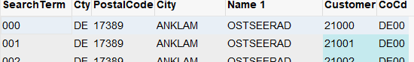

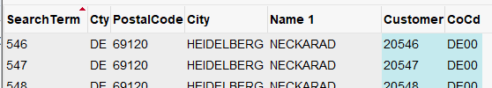

6.3. What is a debitor? (2.5 points)  
A debitor is an individual or a business that has purchased a product or service from another business and owes them money.